Exploratory Data Analysis (EDA)

1. Auto MPG Dataset

Introduction

This analysis is conducted on the Auto MPG dataset obtained from the UCI Machine Learning Repository. This dataset contains information about various automobiles and their fuel efficiency.

The primary objective of this dataset is:

To predict the fuel efficiency (miles per gallon - MPG) of a car based on the technical characteristicsThis dataset consists of the 398 Observations
1. Predictive Variables (Features)
cylinders, displacement, horsepower, weight, acceleration, model_year, origin
(If car_name exists, it is treated as non-numeric and is typically excluded for basic linear regression ).

2. Target variable: mpg (miles per gallon)
The prediction task is a regression problem, since the target variable(mpg ) is continuous.

Data Preprocessing:
Dataset obtained from the UCI Machine Learning Repository
Retrieved programmatically using the ucimlrepo Python package and ID used: 9 (Auto MPG dataset).

The returned object contains:
- auto_mpg.data.features → Independent variables (pandas DataFrame)
- auto_mpg.data.targets → Dependent variable (pandas DataFrame)
- auto_mpg.metadata → Dataset description and source details
- auto_mpg.variables → Column-level information

Dataset Dimensions
The dataset contains 398 rows (observations),The dataset contains 8 columns (features + target).

Column Names
The dataset includes the following variables:
- displacement
- cylinders
- horsepower
- weight
- acceleration
- model_year
- origin
- mpg (target variable)
Shape of dataset: (398, 8).
Numerical Distribution:
Float columns: displacement, horsepower, acceleration, mpg
Integer columns: cylinders, weight, model_year, origin

Missing Value Analysis
horsepower column contains 6 missing values out of 398 observations.
All other variables contain complete data.
Missing percentage in horsepower:
$$\frac{6}{398}≈1.5\%$$
Since missing data is very small (< 5%), it does not significantly affect overall dataset structure.
We dropped that records which has null values, since there are only few records

Heat Map
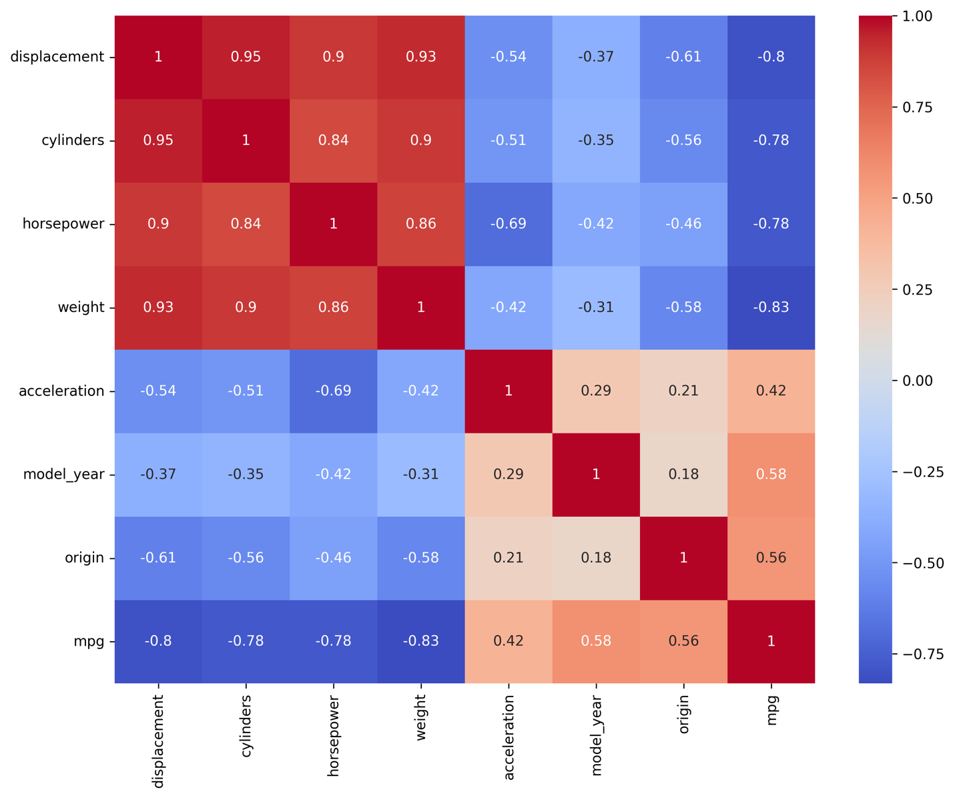

Correlation Analysis
Strong negative correlation observed between mpg and engine-related features such as weight, displacement, horsepower, and cylinders.
model_year and origin show moderate positive correlation with mpg.
High inter-correlation among displacement, cylinders, and weight indicates potential multicollinearity.

Box Plots :
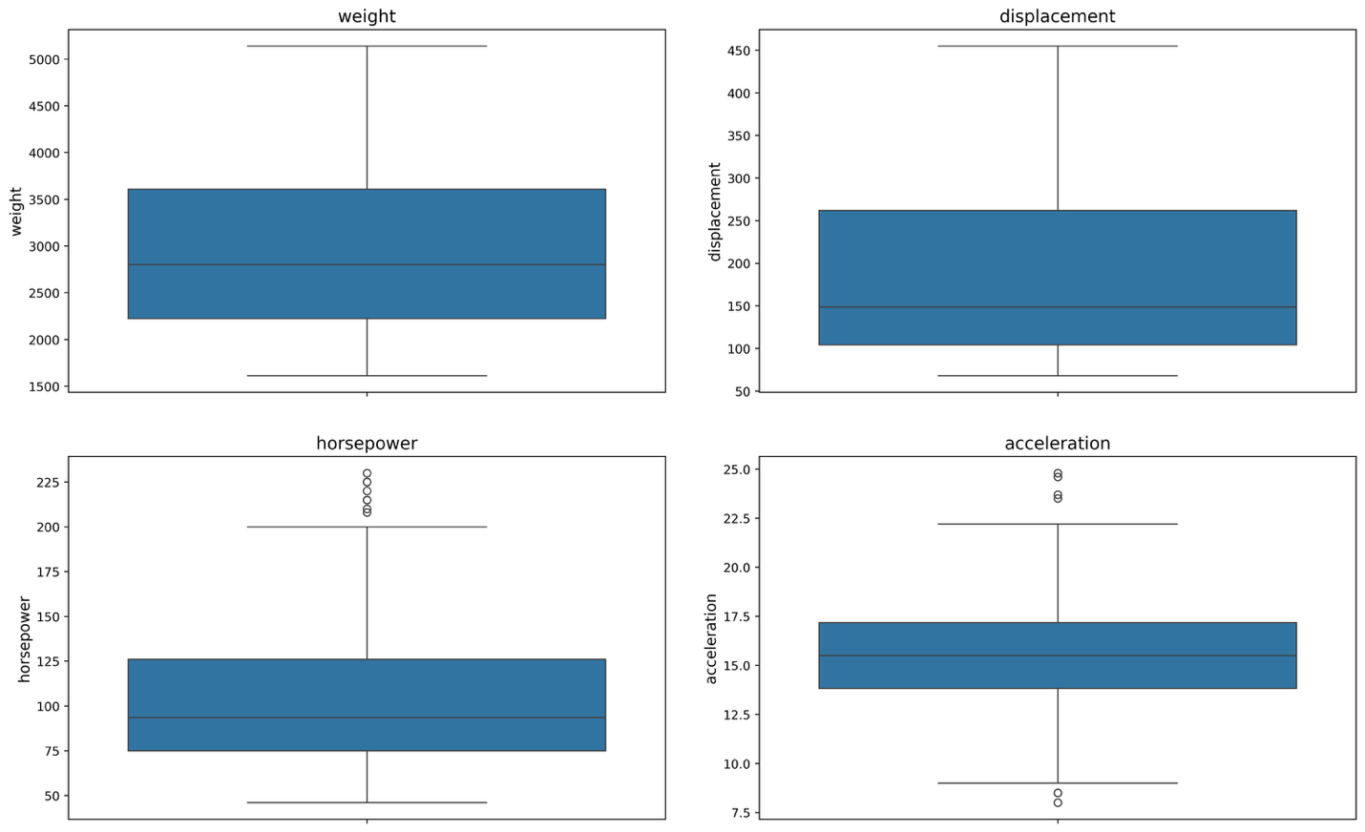

Weight and displacement show wide spread but no extreme outliers.
Horsepower contains a few high-value outliers and is slightly right-skewed.
Acceleration shows moderate spread with minor outliers on both ends.
Overall, variables exhibit reasonable variability; only horsepower may require attention during modeling.

Count Plots :
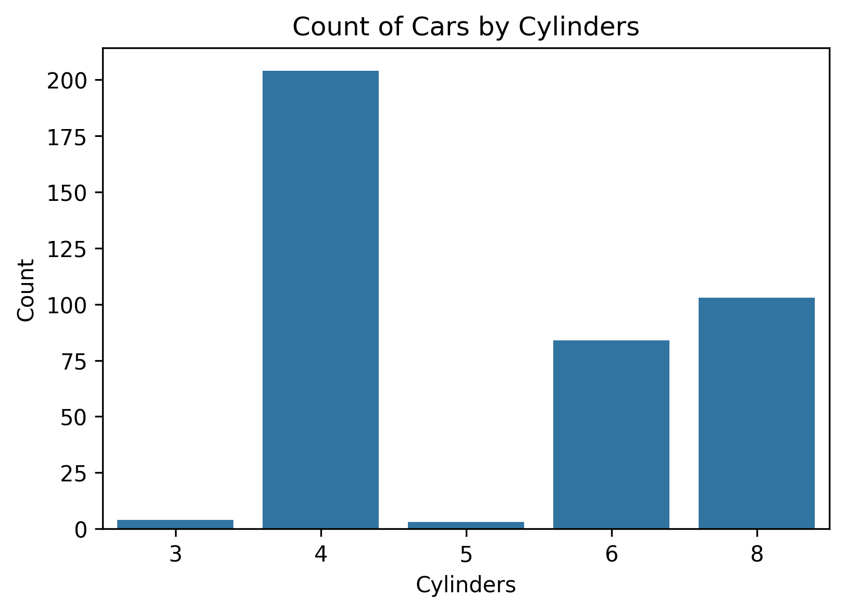

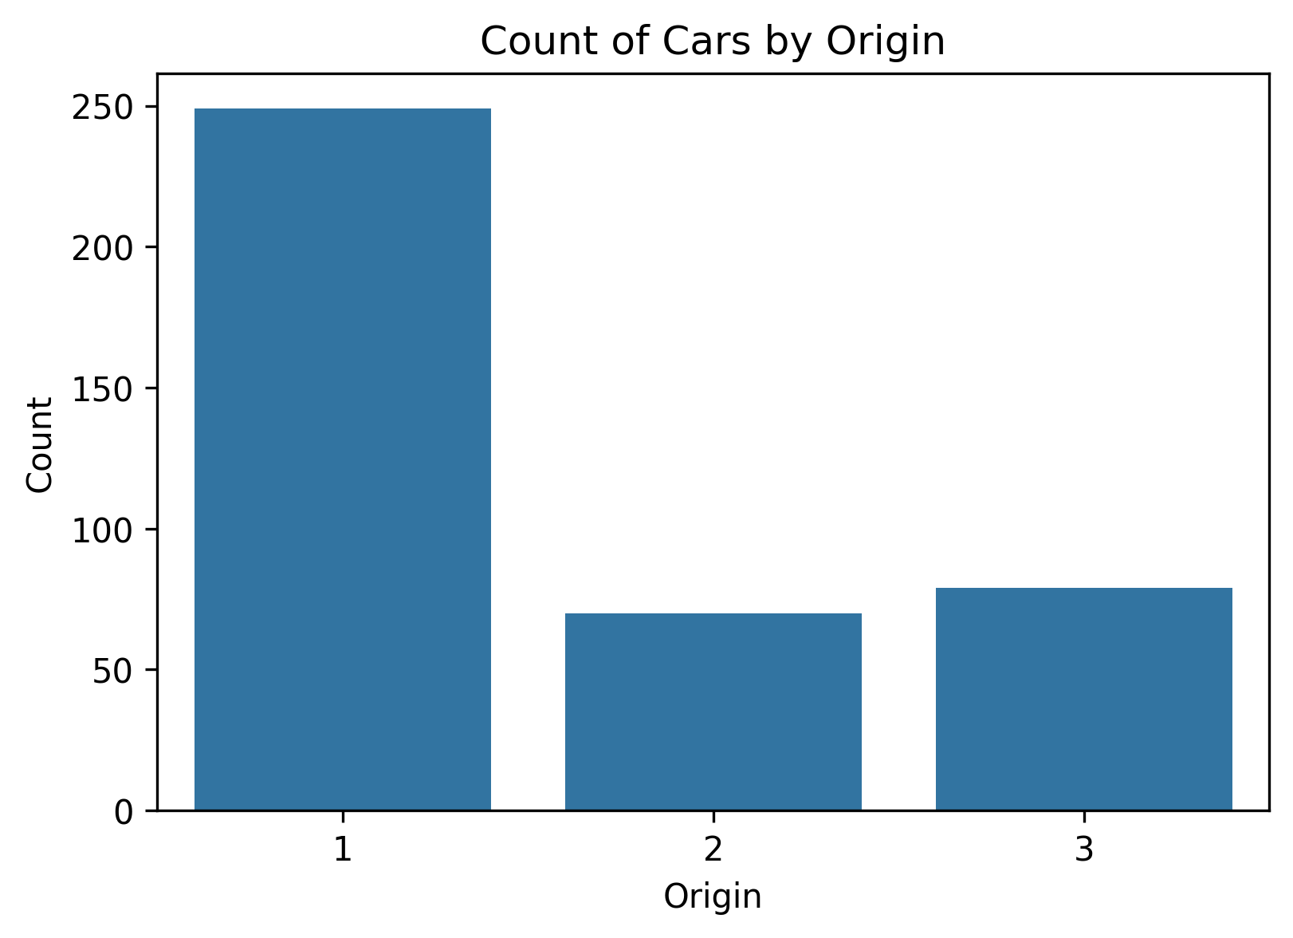
Most vehicles have 4 cylinders, making it the dominant engine type.
Very few vehicles have 3 or 5 cylinders, indicating class imbalance.
A substantial number of vehicles have 6 and 8 cylinders, but significantly fewer than 4-cylinder cars.
Majority of cars originate from Origin 1 (USA).
Origins 2 and 3 (Europe and Japan) have fewer observations, showing dataset imbalance across regions.

Scatter Plot Observations

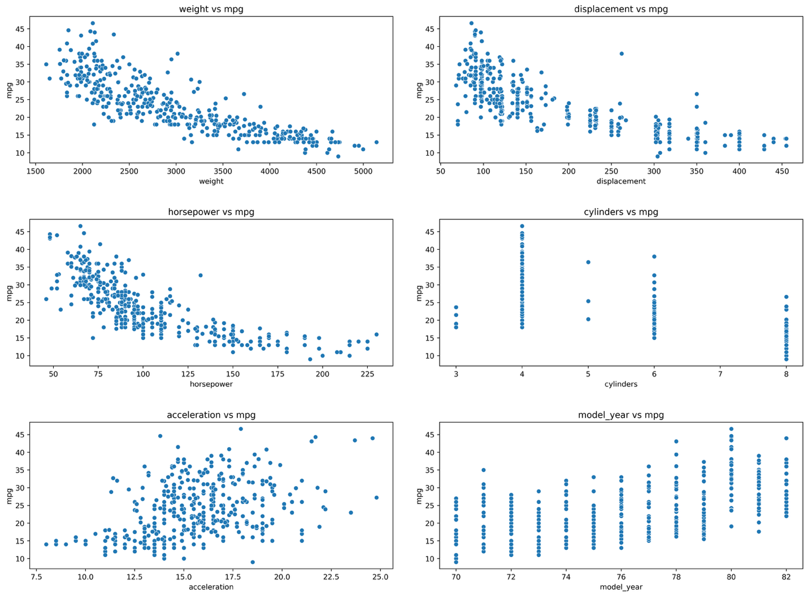
Weight, displacement, horsepower, and cylinders show strong negative relationships with mpg — higher engine size and vehicle weight correspond to lower fuel efficiency.
Model_year shows a clear positive trend with mpg — newer cars tend to have better fuel efficiency.
Acceleration shows a weak to moderate positive relationship with mpg.
Relationships appear largely linear, supporting the use of linear regression.
No extreme structural anomalies are observed, though some spread increases for lighter vehicles.
2.House Price Regression Dataset
Introduction
This analysis is conducted on the House Price Regression Dataset.
The dataset contains structural and location-related attributes of houses along with their market prices.
The primary objective of this dataset is to predict the House_Price based on housing characteristics.
The dataset consists of 1000 observations.
Predictive Variables (Features)
- Square_Footage
- Num_Bedrooms
- Num_Bathrooms
- Year_Built
- Lot_Size
- Garage_Size
- Neighborhood_Quality
Target Variable
- House_Price
The prediction task is a regression problem, since the target variable (House_Price) is continuous.
Dataset Dimensions
The dataset contains 1000 rows (observations).
The dataset contains 8 columns (7 features + 1 target).
Shape of dataset: (1000, 8).
Data Types
6 columns are of type int64
  - Square_Footage
  - Num_Bedrooms
  - Num_Bathrooms
  - Year_Built
  - Garage_Size
  - Neighborhood_Quality
2 columns are of type float64
  - Lot_Size
  - House_Price
No object or categorical string columns are present.
Missing Value Analysis
All columns contain 1000 non-null values.
No missing values are present.
Missing percentage in dataset: 0%.
No imputation or deletion was required.
Heat Map:
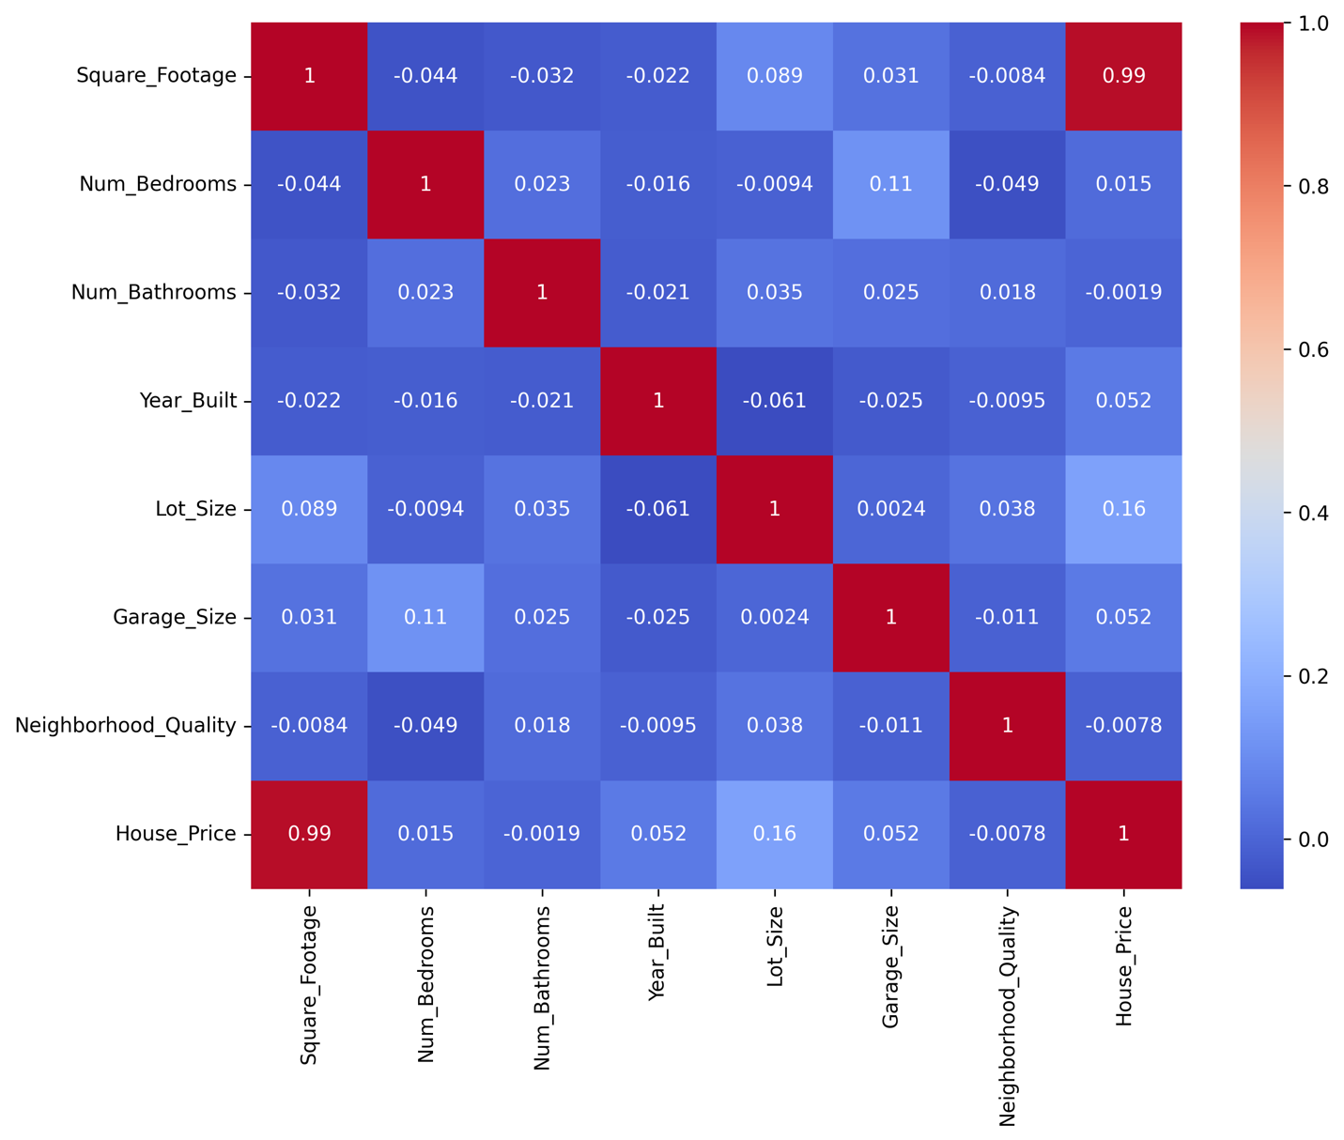
Square_Footage and House_Price show extremely strong positive correlation (0.99).
Lot_Size shows weak positive correlation (0.16) with House_Price.
Year_Built shows very weak correlation (0.052) with House_Price.
Num_Bedrooms and Num_Bathrooms show near-zero correlation with House_Price.
No strong multicollinearity exists among independent variables.

Distribution Analysis of Continuous Variables
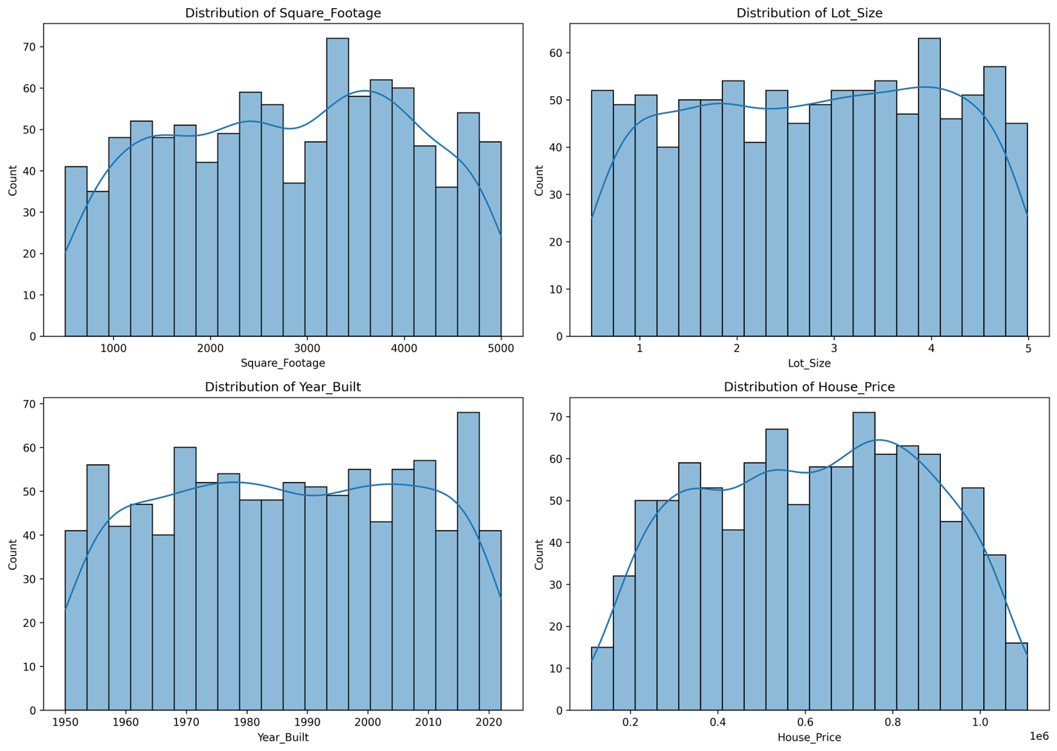Square_Footage
Square footage ranges from approximately 500 to 5000 sq.ft. The distribution appears relatively uniform across the range.No strong skewness is observed.There is substantial variability in property sizes.This wide variation suggests square footage may strongly influence house price.
.Lot_Size
Lot size ranges from approximately 0.5 to 5 units.The distribution is fairly evenly spread.No significant skewness or extreme outliers are visible.The spread indicates moderate variability across properties.Further analysis is required to assess its impact on price.
Year_Built
Houses were constructed between 1950 and 2022.The distribution is relatively balanced across decades.No strong clustering in a specific time period is observed.Both older and newer houses are well represented.The effect of construction year on price requires bivariate analysis.
House_Price
House prices range from approximately $111,626 to $1,108,237.The distribution shows moderate spread across the price range.No severe skewness is evident.There is considerable variability in housing prices.The wide price range confirms suitability for regression modeling.
Distribution Analysis of Discrete Variables
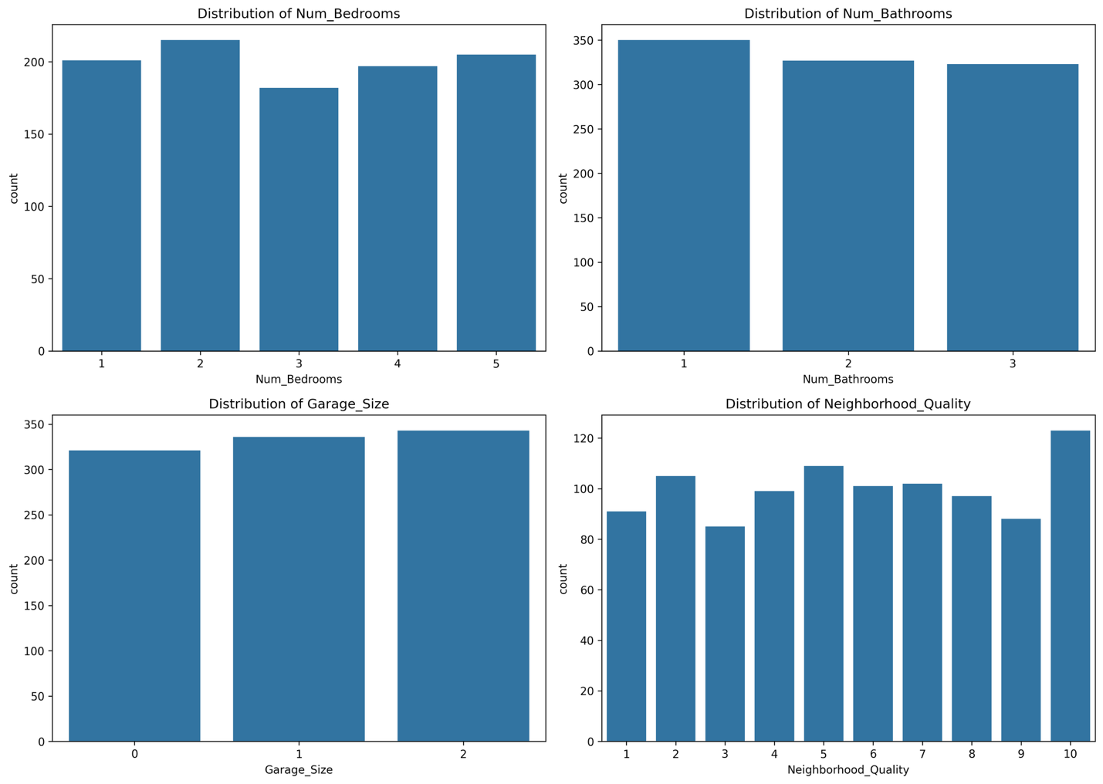 Num_Bedrooms
The number of bedrooms ranges from 1 to 5.The distribution appears relatively balanced across categories.Houses with 2 and 5 bedrooms are slightly more frequent.No extreme imbalance is observed.Bedroom count alone may not strongly differentiate house prices.
Num_Bathrooms
Bathrooms range from 1 to 3.Properties with 1 bathroom appear slightly more common.The distribution is fairly uniform across categories.The limited range reduces variability.Its influence on price requires bivariate analysis.

Garage_Size
Garage size ranges from 0 to 2.The three categories are nearly evenly distributed.No dominant category is observed.The balanced distribution suggests stable representation.The impact on price must be evaluated using scatter or correlation analysis.
Neighborhood_Quality
Neighborhood quality ranges from 1 to 10.The distribution is fairly spread across all quality levels.Slightly higher counts appear in mid-to-high quality ranges.No severe skewness is visible.This variable may have moderate influence on house prices depending on correlation results.
Bivariate Analysis: Features vs House_Price
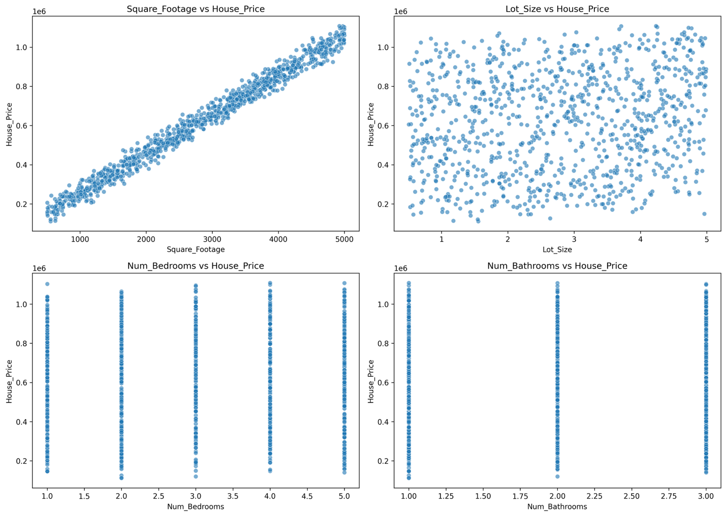 Square_Footage vs House_Price
A very strong positive linear relationship is observed.As square footage increases, house price increases proportionally.The points are tightly clustered along a straight upward trend.This indicates extremely high correlation (≈ 0.99).Square_Footage is the strongest predictor of House_Price.
Lot_Size vs House_Price
The scatter plot shows a widely dispersed pattern.No clear linear trend is visible.The relationship appears weak.This aligns with low correlation (~0.16).Lot_Size has limited predictive strength.
Num_Bedrooms vs House_Price
Vertical strip pattern is observed due to discrete values (1–5).No strong increasing price trend across bedroom categories.Prices vary significantly within each bedroom count.Weak relationship is indicated.Num_Bedrooms alone is not a strong predictor.
Num_Bathrooms vs House_Price
Similar vertical strip pattern due to discrete values (1–3).No clear monotonic increase in price.Price variation is high within each bathroom category.Weak association with target variable.Limited standalone predictive power.

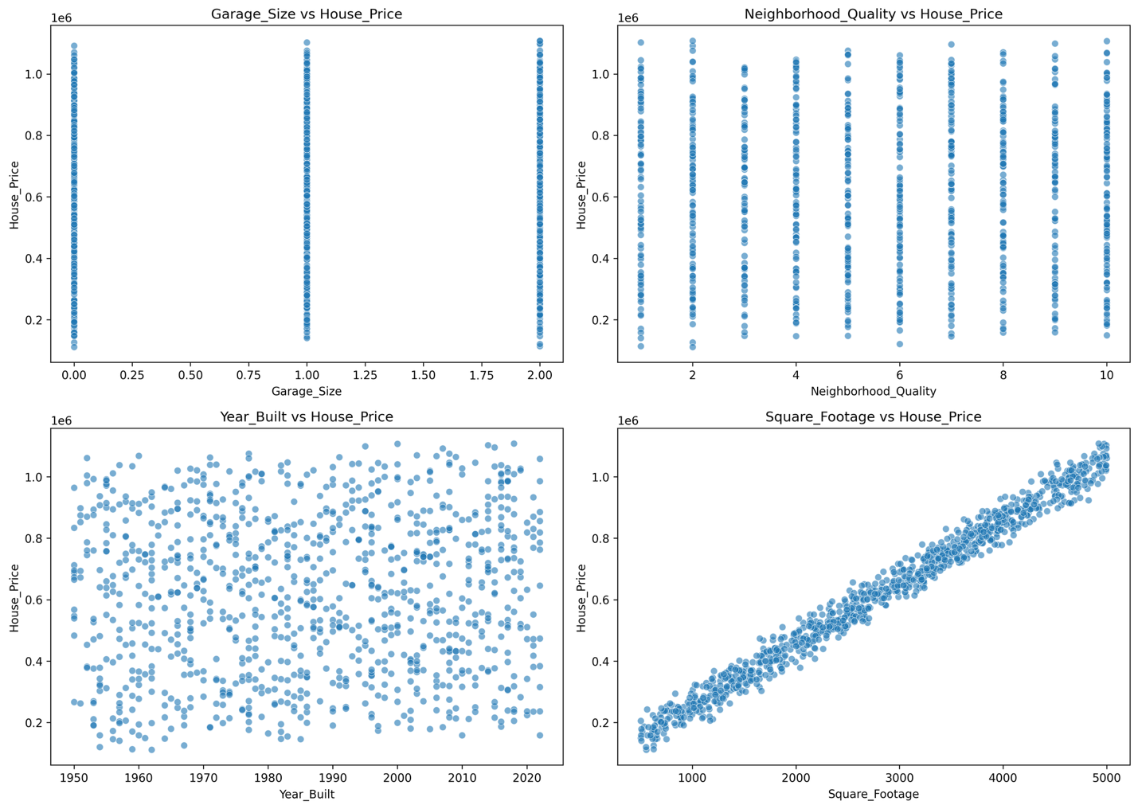

Garage_Size vs House_Price
A vertical strip pattern is observed due to discrete values (0, 1, 2).Prices vary widely within each garage category.No strong linear upward trend is visible.The relationship appears weak.Garage_Size alone is not a strong predictor of price.
Neighborhood_Quality vs House_Price
Discrete vertical clusters are visible (values 1 to 10).Slight upward tendency is noticeable as quality increases.However, price variation remains high within each category.The relationship appears moderate but not strong.Neighborhood_Quality may contribute moderately to price prediction.
Year_Built vs House_Price
Scatter points are widely dispersed.No clear increasing or decreasing linear trend is visible.Both old and new houses show wide price variation.Weak relationship is indicated.Year_Built does not strongly determine house price independently.
Square_Footage vs House_Price (Repeated for comparison)
Very strong positive linear relationship is observed.Points follow a tight upward trend.Correlation is extremely high (~0.99).Minimal dispersion around the line.Square_Footage remains the dominant predictor.

3.Medical Cost Personal Dataset

1. Introduction
This analysis is conducted on the Insurance dataset obtained from Kaggle.
This dataset contains demographic and health-related information of individuals along with their medical insurance charges.
The primary objective of this dataset is:
To predict the medical insurance charges (charges) based on demographic and health-related characteristics.
This dataset consists of 1,338 observations.
Predictive Variables (Features)
- age
- sex
- bmi
- children
- smoker
- region
Target Variable
- charges (medical insurance cost)
The prediction task is a regression problem, since the target variable (charges) is continuous.
Dataset obtained from Kaggle:
https://www.kaggle.com/datasets/mirichoi0218/insurance
The dataset is provided as a CSV file (insurance.csv).
Dataset Dimensions
The dataset contains 1,338 rows (observations).
The dataset contains 7 columns (features + target).
Shape of dataset: (1338, 7).
Data Types
3 columns are of type int64 → age, children
2 columns are of type float64 → bmi, charges
3 columns are of type object → sex, smoker, region

Numerical Distribution
Continuous Variables: age, bmi, charges
Discrete Numerical Variable: children
Categorical Variables: sex, smoker, region

Missing Value Analysis
No missing values are present in the dataset.
All 1,338 observations are complete.
Missing percentage in all columns: 0%
Since there are no missing values, no imputation or deletion is required.
Histogram of Continous Variables

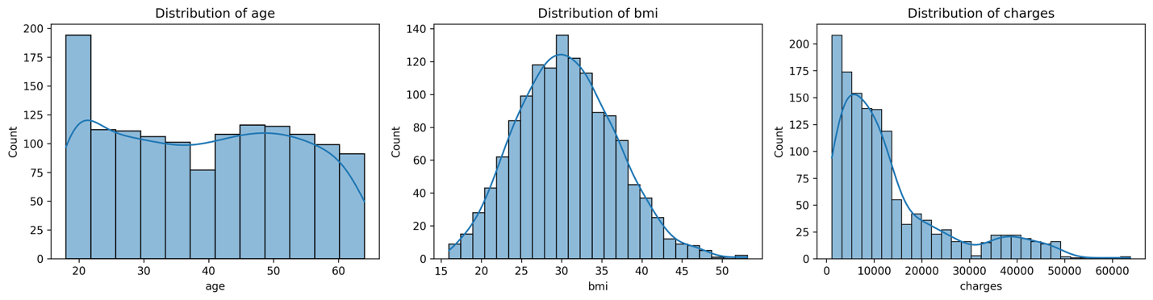
Charges distribution is highly right-skewed. Age distribution is fairly uniform across adult range.BMI is approximately normally distributed with slight right skew. Charges show large variance compared to other variables. Skewness in charges suggests possible log transformation.
Boxplots (Outliers)
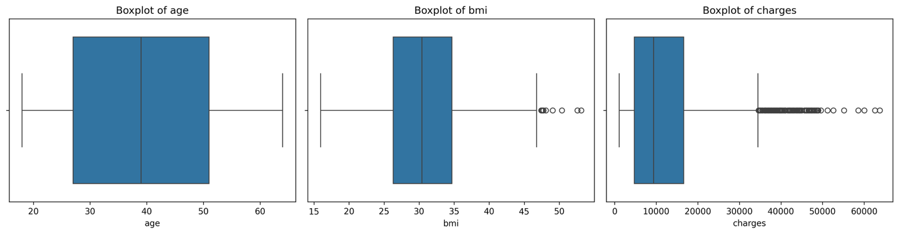
Charges contain significant high-value outliers.BMI shows moderate outliers.Age does not show extreme outliers.Charges variability is much larger than other variables.Outliers may influence regression performance.

Countplots (Categorical Variables)
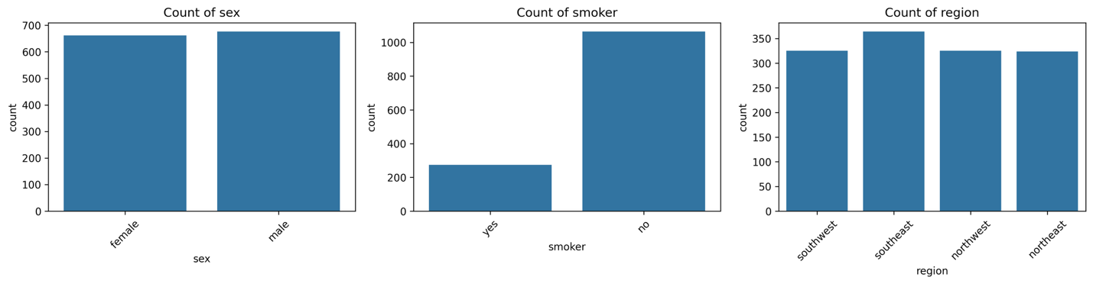
Gender distribution is nearly balanced.Non-smokers are more frequent than smokers.Regions are relatively evenly distributed.No major imbalance in categorical predictors.Smoker category likely impactful despite lower frequency.
Children Distribution :
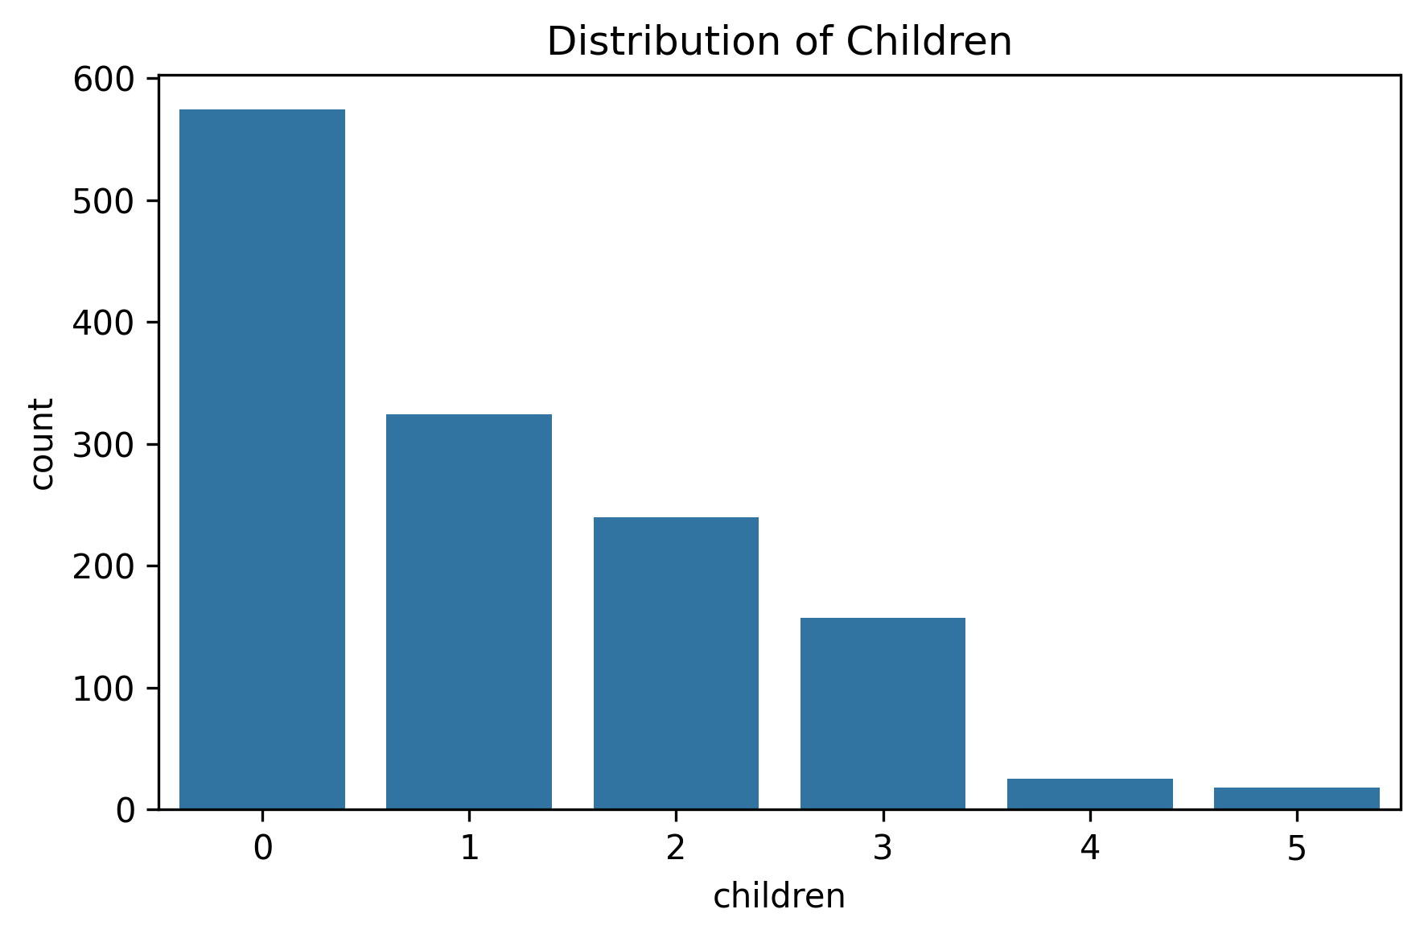
Majority have 0–2 children.Few observations for higher number of children.Distribution is right-skewed.Variable has limited range.Impact on charges appears minor but requires further testing.

Scatterplots (Continuous vs Charges)
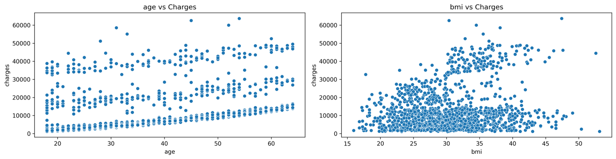
Age shows positive relationship with charges.BMI shows moderate upward trend with charges.Charges variability increases at higher age and BMI.Evidence of heteroscedasticity.Possible non-linear relationship exists.
Categorical vs Charge s (Boxplots)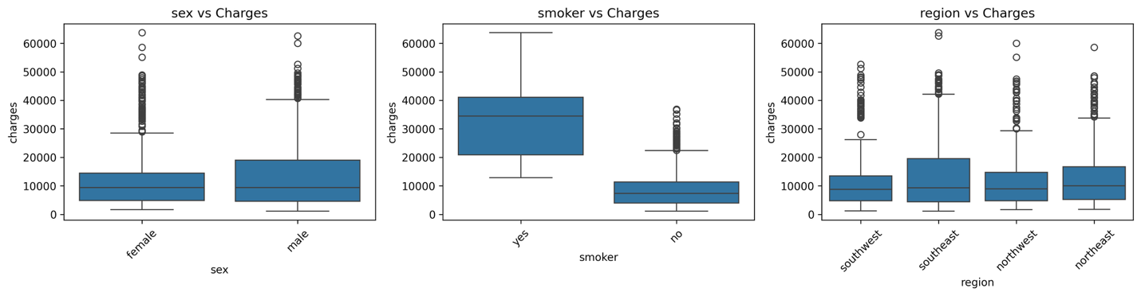
Smokers have significantly higher charges.Clear separation between smoker and non-smoker groups.Gender difference in charges is minimal.Regional differences are small.Smoker variable appears strongest categorical predictor.
Heatmap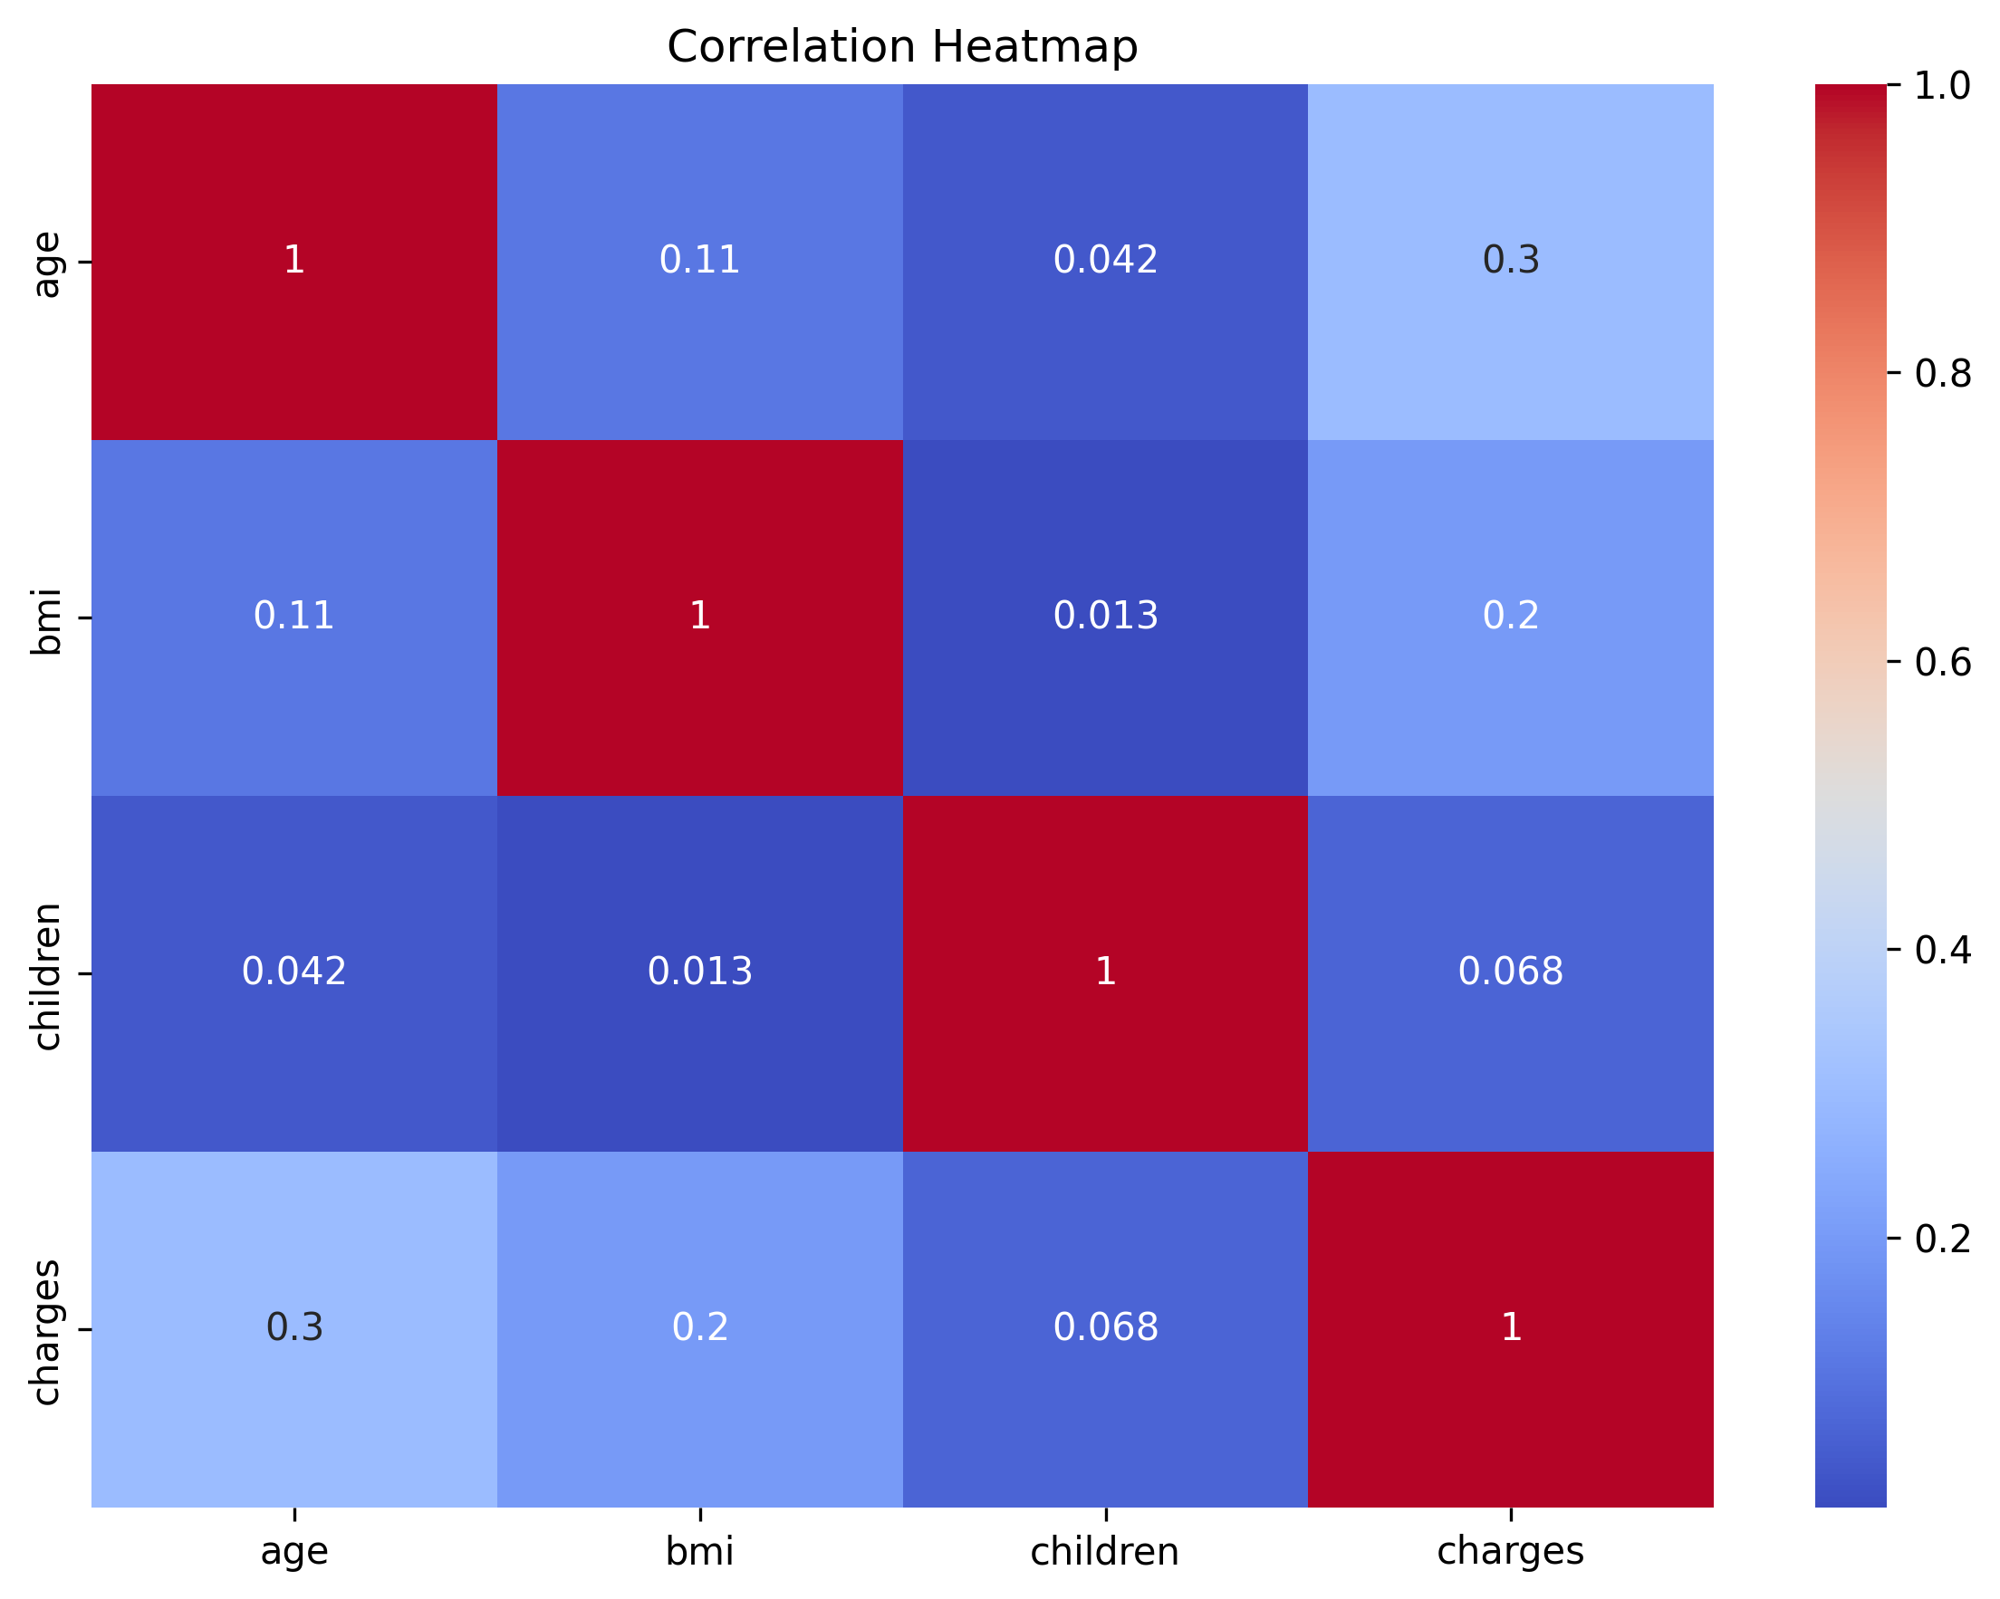
Strongest correlation with charges: smoker. Moderate correlation: BMI and age. Weak correlation: children. No severe multicollinearity among numeric features. Age, BMI, and smoker likely key predictors.

